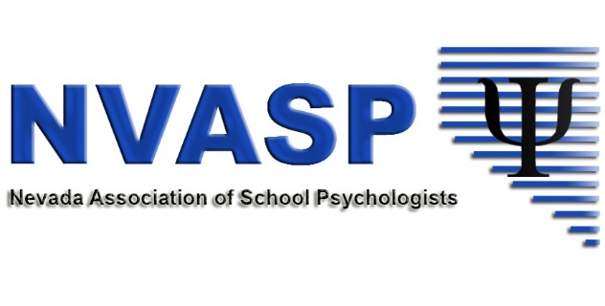

Open Meeting
September 24, 2018
Alamo Elementary
Las Vegas, NV
Zoom Meeting #919925822

I. Call to order
A. Members present: Emma Dickinson, President; Stephanie Patton, Secretary; Andrea Walsh, NASP Delegate; Paige Beckwith, Director at Large; David Nomicos, Director for Minority; Corie Hyatt, member
B. Approval of Minutes
a. 2018 Leadership Minutes: Motion made by Emma to approve minutes; motion seconded by Stephanie; all in favor
b. August 2018 Minutes: Motion made by Emma to approve minutes; motion seconded by Andrea; all in favor

II. Celebrations
- Andrea – we made it through September (almost)
- David – currently supervising a practicum student, and it is going well
- Emma – feeling organized this year

III. Open Issues
- Community Agreements: reviewed community agreements established at 2018 Leadership retreat
- Zoom account – should NVASP purchased an account for $14.99?
  - Discussion: the Zoom account can be used for ongoing board meetings but also by committees in order to meet on a regular basis. Purchasing a zoom account will allow unlimited use without time limits on meetings.
  - Motion made by Emma to purchase Zoom account for $14.99; motion seconded by Andrea; all in favor
- Conference Debrief
  - NVASP made $6,445 in income from registration
  - Exact expenses not yet known, waiting on invoice from Dr. Kelly-Vance and possible some individual reimbursements; payment sent to Dr. Shriberg.
  - Danielle (as reported by Emma) estimates between $3100 and $3200 in expenses
  - Exact numbers and profit should be available by next board meeting
  - We need to revamp how we proceed with conferences by creating a timeline of things that must be done and when as well as lists of responsibilities; Andrea suggested this should be done within the month to ensure we remember all the difficulties; Stephanie to create a shared document with bullet points; Everyone involved in the 2018 conference should contribute and possible schedule an informal Zoom meeting to follow-up
- Financial Accounts (as reported by Emma)
  - As of 9/14 $6,819.95 in Bank of America account
  - As of 9/14 $12,910.88 in PayPal account
  - Continuing to experiment with transferring more than $1,000 per month. Danielle was able to transfer $5,000 in September without known reason
  - Following up with Bank of America to secure direct merchant services for NVASP website
- Board Communication
  - Discussion regarding the use of emails, group texts, etc. to communicate; Andrea suggested that when board members email one another regarding NVASP, cc all members; Stephanie suggested that all members have a dedicated NVASP email and that is the only email to be used for NVASP communication; All members to be invited to possible Team Drive or NVASP folder
  - Refrain from texting and stick to emails unless there is a need for immediate response; respect board members’ personal time
- Outside Research Projects
  - NVASP has received at least three requests recently to use membership to send out surveys; in the past NVASP has agreed to do this as long as someone on the board knew the researcher
  - Does NVASP need an official policy?
    - NASP does not allow any emails out to members; NVASP should consider whether we share members’ information with third parties
    - Perhaps we can create a way to allow members to “opt in” to surveys – Stephanie to research how to do this on membership page
    - We could post links to surveys on our website and/or facebook page in the meantime
    - Should direct messaging from NASP be an exception?
      - Distinguish between calls to action and assisting research
      - NVASP should continue to push out calls to action
      - Emma to draft preliminary policy for review at October board meeting
- Short Term Goals
  - NVASP needs to move forward with setting short term goals now that the conference is complete
  - Legislative session is a priority this year
  - Continue to think about how professional development is provided and consider lecture series instead of conferences
  - Think back to goals we set during the 2017 Leadership Retreat
  - Everyone to think on this and share ideas in a google document and bring them to discuss at October board meeting

IV. Committee Updates
- Communications Committee
  - SPAW – some ideas to get membership involved and excited in SPAW (unlocking potential). NASP has a lot of resources and materials that we can share without membership; consider implementing a contest or raffle during SPAW week to encourage members to engage in self-care and/or show gratitude for their colleagues
- Shortages Committee
  - Tracee not in attendance
  - Emma reporting for Tracee: start looking at NVASP goals regarding shortages
  - Two webinars coming up
  - David reported about a previous webinar that we have likely missed our window to submit a survey
- NASP Delegate Report
  - NASP has a Leadership in Action initiative to present to high school students during SPAW week about the profession; program created by Charles Barrett; boards send in how many students they’ve reached; Perhaps we can encourage members to do this by allowing them to enter the SPAW raffle
  - Regional Leadership Meeting (RLM)
    - Emma and Andrea are going (paid for my NASP) and can bring 3 guests (more if approved); Andrea suggested all board members go and NVASP covers registration ($150/each) and provide a travel stipend similar to what is provided by NASP ($500/each); It is possible that providing these sorts of opportunities would encourage more members to get involved with NVASP and run for board positions
    - RLM: February 24, 25 before NASP Conference (February 26 – March 1)
    - Andrea suggested that board will read “The Will to Govern Well” before the RLM since the author will be presenting and this was highly recommended by NASP
    - Stephanie suggested NVASP go ahead and purchase books for voting board members. Motion made by Emma to purchase six copies of “The Will to Govern Well;” seconded by Andrea; all in favor
  - There is another virtual hill day on 11/14
  - There will be more discussion regarding the RLM during October board members; board should decide by then whether they are interested in going
- UNR Task Force
  - Paige will begin working on this initiative now that conference is completed; will provide more information at October meeting

V. Updates to by-laws and website
A. Emma to discuss with Tracee about updates; should be created and voted on ASAP

VI. Leadership in Action Spotlight
- NASP wants us to nominate our colleagues
- NVASP board members should all nominate at least one person; Andrea suggested we nominate people who do not always get recognized for the great work they do

VII. NVASP Awards
- Board wants to continue with award, nominations were to go out in the Fall to be completed before the end of the year
- Emma to revisit awards

Open Meeting Adjourned

