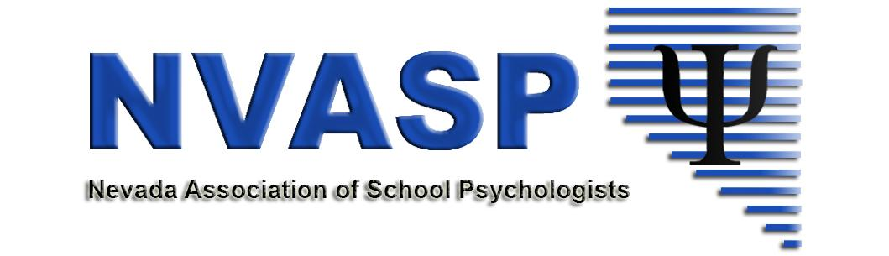
NVASP Monthly OPEN MEETING
Location: Zoom online
Date: 12/18/2018
Attendees:
Time: 4:00 PM
- Call to order
- Roll call
- Approval of Minutes –Last Meeting
- Open Issues – I = Information, A= Action, D= Discussion
  - Celebrations – (professional, personal, anything!!!)
  - (All-I) Community Agreements (Don’t be afraid to speak up, agree or disagree respectfully, others?)
  - (All, A, I) Conference Follow-ups
    - Procedures/policies for the future
  - (D, All) Communication
    - Reminder to send out link for review if a new google document is created.
    - Other issues?
  - (All- A, D) NVASP Short Term Goals: https://docs.google.com/document/d/115n57LOGe--0fOwJLOnNsq9ImoeeTA7MbcEvpH7vd64/edit?usp=sharing
    - What do we want to accomplish in the next two years?
    - Next steps?
  - (I, D) Leadership in Action Spotlight (liAS)- Nominations submitted? Stephanie Patton nominated
  - (I) Position, Committee and Task Force Updates
    - (D. Shaw) Financial Updates-
    - MHS Advertisement
    - (S. Patton) Communications Director
      - Mailing address update-Keep at Beth Howe Center
    - (K. Dockweiler) GPR/Shortages - gearing up for the next legislative session.
      - Work with the Collaborative
    - (A. Walsh) NASP Delegate Report
      - Registration for RLM
      - NVASP Sponsored RLM participants - Reimbursement procedures? Is a form needed?
      - Other
    - (I, P. Beckwith) UNR Task Force Update
  - Tabled/Ongoing
    - (All – D) By-Laws/Website updates
    - (E.Dickinson-D) The Will to Govern Well -future work
    - (D, A) NVASP Awards/Recognitions
- New business
  - Begin planning for 19-20 Lecture series
    - (K. Dockweiler) MHS has reached out on Dr. Ortiz’s behalf. What date would we like him to come out?
  - Next meetings will be every Third TUESDAYS of the month: Jan 15, Feb 19, March 19, Skip April, May 21.
  - Next Safe and Respectful Learning Environment Meeting will be in January.
- Adjournment

